Medical imaging and display monitors.
MEDICAL AND IMAGING PRODUCTS

- Medical Records & Employee data storage systems
- Medical Imaging and Vision systems
- Laboratory Data Acquisition systems
- Integrated Portable workstations


Medical Imaging Products

Product Menu : Studio9000-MVR And MedPAC-15

Studio9000-MVR™

Uses powerful image acquisition technology and non-proprietary frame grabbing components to help medical practitioners gather more precise diagnostic information on their patients. The MVR and MedPAC™ is a revolutionary and cost effective imaging solution designed for modern O&G medical practitioners.  With this solution, oncologist and gynecologist can provide in-depth analysis of their patient's health through the use of high quality medical imaging software solutions.  The system can be interfaced to any high speed medical X-Ray camera or video colposcope to capture, measure and manipulate images of the cervices and surrounding region as an example. | 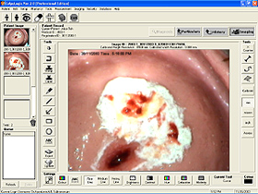  Application Example: Colposcopy Imaging 3rd part Software

Other complimentary features include a versatile database that stores and retrieve patient's historical medical information and images efficiently and systematically via a user-friendly software interface. Whatever your needs maybe, the Vision systems has the software features you need.

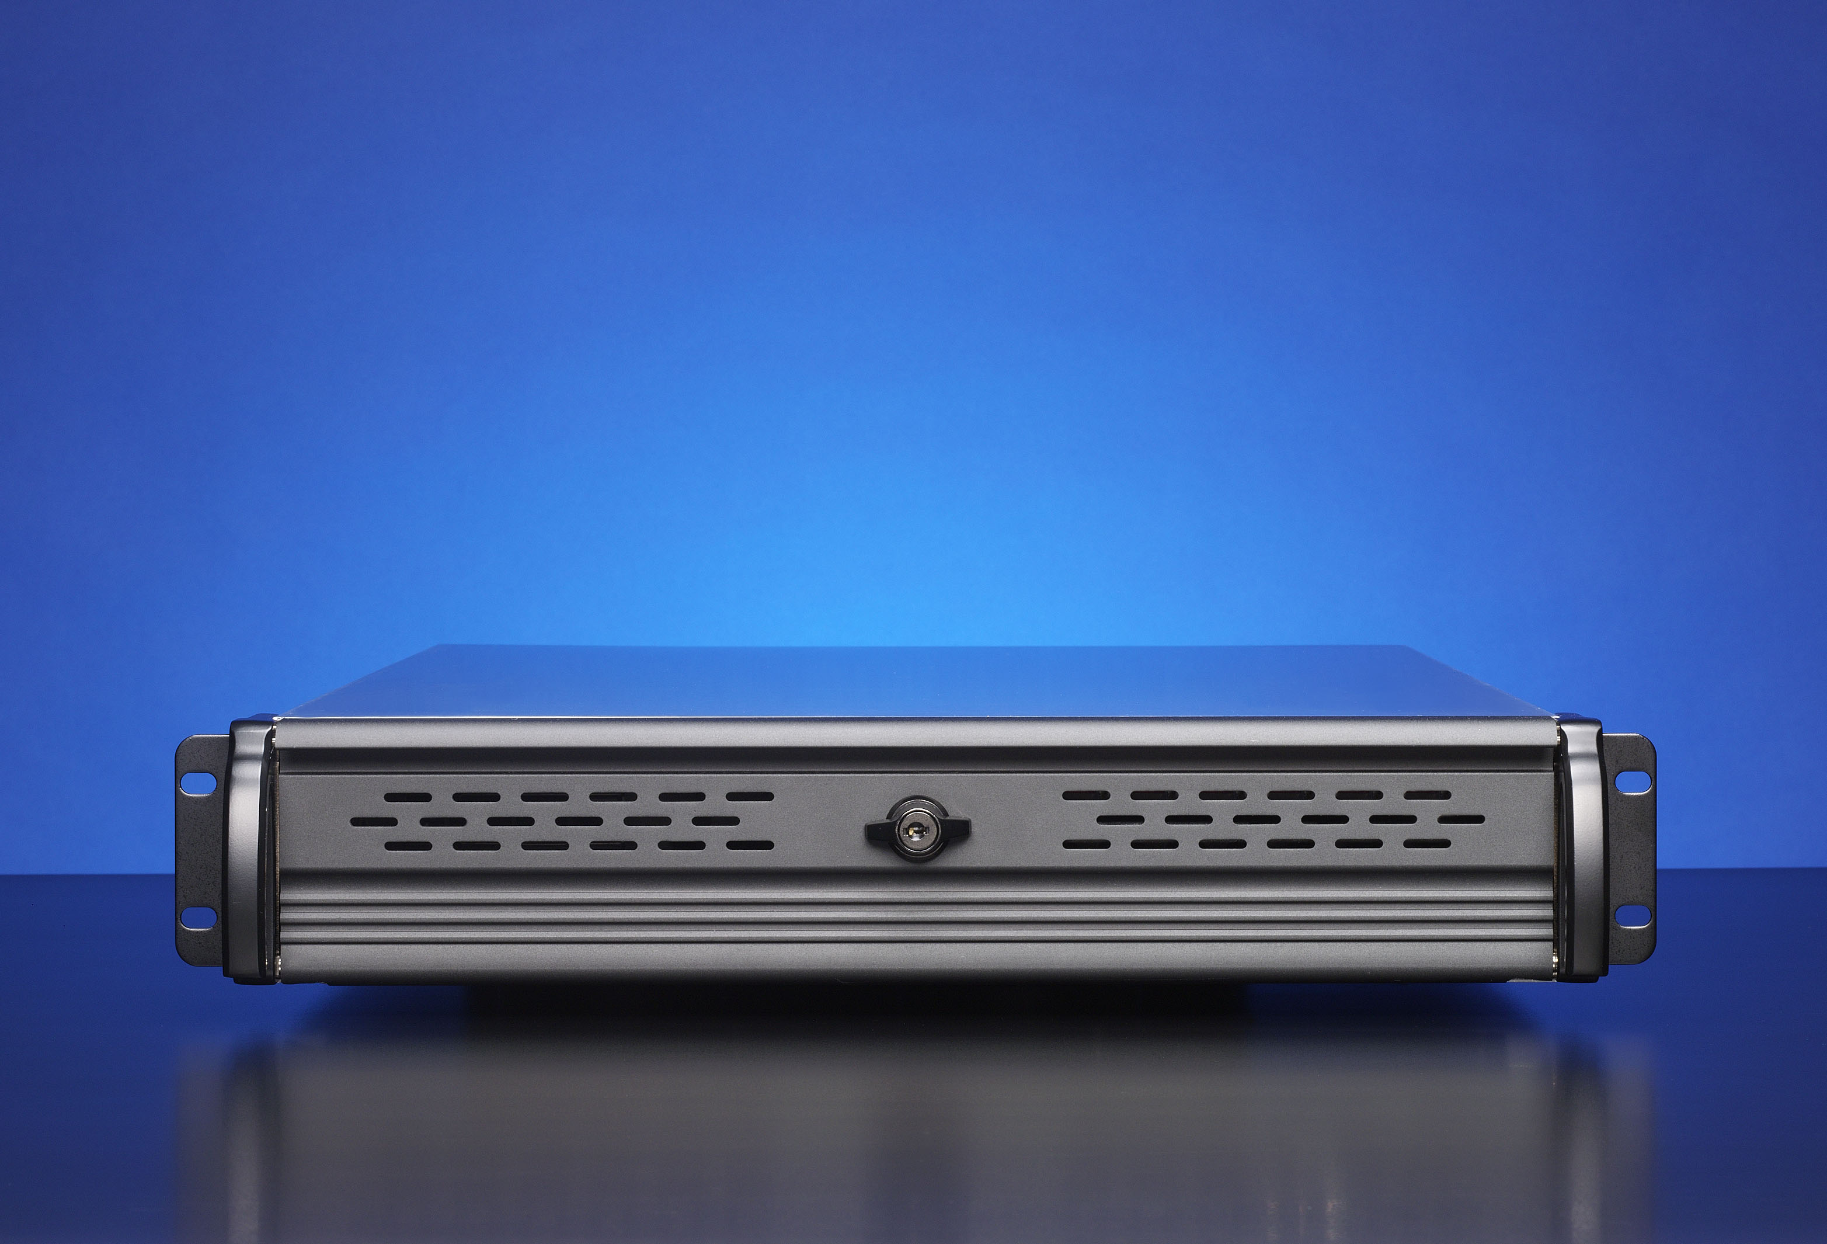
Advance Image Management

Features  - Advance Image management, DICOM support. 8,12,16-bit grayscale and color. LUT  - C T Scanning, X-Ray Image management  - Image management for tracking changes on the cervical surface  - Powerful lesion tagging features makes it easy to locate lesions and track it over time  - Compatible with most digital and analog video cameras, colposcopes and medical imaging cameras  - Side by side quartet image comparison for before and after treatment comparison  - Image enhancement tools (brightness, contrasting and color adjustment) for image clarity  - Image labeling, pointers and measurement tools  - Unlimited image buffering and storage | 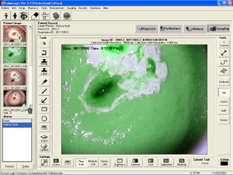  Using 3rd party ColpoLogix Ver 2.0 Professional Edition  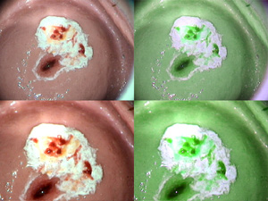  Side by Side Quartet Image Comparison

Patient Records Management
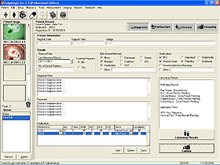 | Features  - Database-organized patient records  - Instant viewing, storage and retrieval of patient’s historical diagnosis, treatment, medication and images  Patient Confidentiality  - Encrypted password protection  - Modesty imaging tool to hide private and sensitive areas

Application Example Screenshots
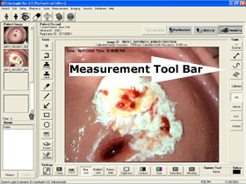 | Measurement Tools  Studio9000-MVR™ and MedPAC-15™ vision system Includes a set of measurement tools which enables the medical practitioner to perform measurements that include  - Counting  - Length measurements  - Area measurements  based on calibrated values.  Unit of measurements can be either millimeter, micron or inch.

Live Video Image Capturing & Buffering
Images are captured and stored in a temporary system buffer. Each of these images can be selected and transfer to the patient’s file. The amount of buffered images depend on the available hard disk space size. | 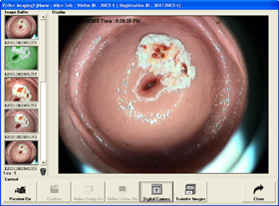

Highlight, Drawing and Annotation Tools
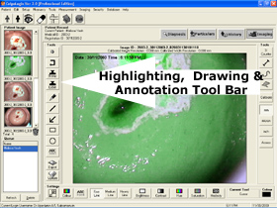 | In addition to power image capturing, MedPAC-15™ also includes a set of drawing tools which enables the user to perform annotation, drawing and highlighting to bring out regions of interest.

User Friendly Interface
As a result of a user friendly interface design, medical practitioners are able to access most of the software features through one single window. This design will enable practitioners to focus on the patient’s illness instead of being bolt down by the complexity of a multi window user interface. | 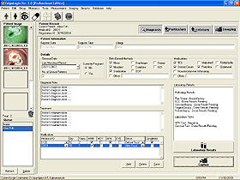

Hardware Specifications
- Studio9000-MVR comes as in a Benchtop/TableTop or Rack mount version
- MedPAC-15 is a Portable Patient Care unit with 15” Crystal Clear LCD Display monitor
- Both units has storage capacities up to 1.2TB for patient data or database.

For more information Contact:
Cepoint Sales Dept..

Contact Information
Sales and Administration Contact:
Telephone
603-883-7979 FAX 603-883-3266
Electronic mail
General Information: Sales: sales@cepoint.com
Customer Support: support@immiintl.com
Cepoint Networks, LLC. © 2006-2009 All rights reserved. No Part or parts of this material may be copied or reproduced in any form without authorization. Information contained in this document is preliminary and subject to change. Cepoint products or products from third part vendors are not manufactured for life support purposes, nor are the products meant or implied for such use. Cepoint Networks, LLC or its representatives shall not be held liable for any loss or damage to life or business resulting from the use, misuse or abuse of its products or third part vendor products. Warranty for Cepoint products is 1-year parts and labor, except as may be indicated in a separate quotation or proposal. Please allow 30-days delivery time frame

